**TAKEAWAYS FROM THE SECOND QUARTER UPDATE**  
*By Louise Sheiner and David Wessel*

The spending and tax policies of federal, state, and local governments—which significantly restrained overall economic growth from 2011 through 2014—had a small positive effect on growth in Gross Domestic Product in the second quarter of 2017, according to the latest reading on the Hutchins’ Fiscal Impact Measure. (The GDP grew at a 2.6 percent annual rate in the quarter, according to the government’s first estimate.)

Smoothing through quarterly ups and downs, the Hutchins’ FIM has been hovering near zero over the past year, suggesting that, on balance, local, state and federal fiscal policies have neither subtracted from nor added to the change in GDP domestic product.

A boost in federal spending this quarter contributed to GDP gains. But those gains were offset by a decline in spending at the state and local levels, which, after recovering slightly last year, have turned down again. While state and local employment has crept back towards its pre-recession levels, it remains 1.4% lower than its peak in 2008 and has fallen over the last two quarters.

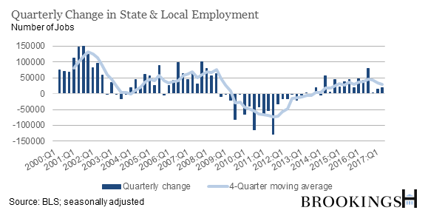

State and local gross investment, despite picking up in 2016, has turned south again. Real construction spending fell to levels 25 percent below its level in 2008.

States face growing pressure to rein in spending (already in 2017, 23 states have made mid-year budget cuts), as well as sluggish revenue growth. But the need to divert tax dollars to shoring up pensions and negative revenue surprises this year has certainly played a role in the continued downturn of state spending. Pension contributions as a share of payroll, for example, have increased by 5.7 percent since 2008.

**RELATED TOPICS**